**Notes: Meiosis**

Cell Division for the formation of egg cells and sperm cells

2.Review: _______________ occurs to help *organisms grow, heal or for asexual reproduction*. It makes more _________________________.

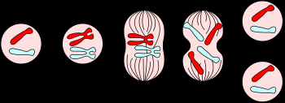

Daughter cells are clones of each other and of the original parent

|  |  |
| --- | --- |
| 3.____________________ are the cells that make up your body: They are body cells.  Ex: | Cells in ovaries and testes will become reproductive cells: These are called  ____________________  Ie: Germ cells eventually become  ____________ and ____________ cells |

4.After ____________________,

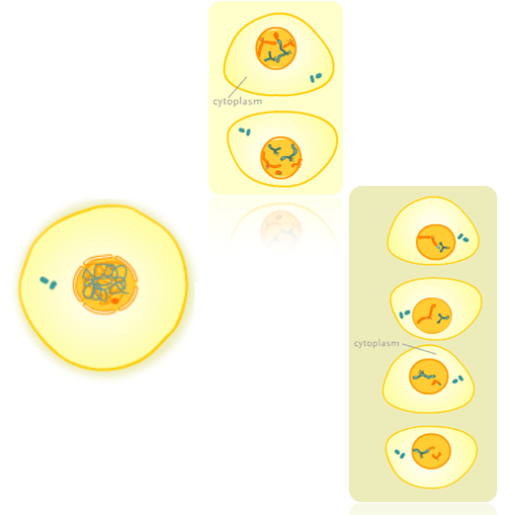

Mitosis:

Somatic Cells

Meiosis:

Germ Cells

**somatic cells** will divide by _______________; **germ cells** will divide by _______________.

Stop &

Think

Mitosis and Meiosis both

Mitosis makes

Meiosis makes

5.____________________ is a specialized type of cell division that occurs in _________________ and ________________________________________________.

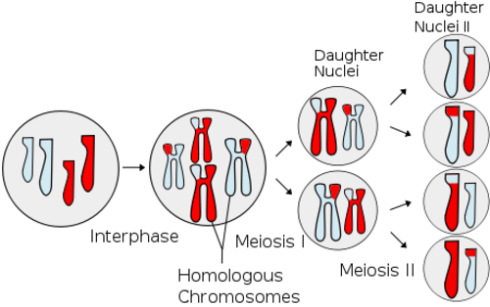Daughter cells are _______________ to each other and have _______________________ of the original parent.

6.Why must reproductive cells have half the DNA of normal body cells?

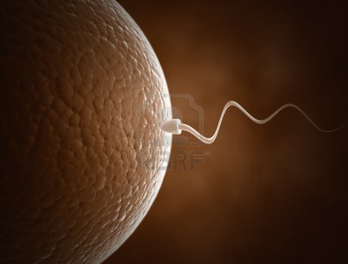

7.Because sperm and egg cells only have ____________________ of the genetic material, they are called _________________________.

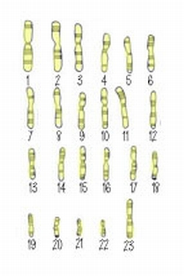In humans, **one set of chromosomes** consists of _________________________. The haploid number: **n**=_____

8.When a haploid egg cell is joined by a haploid sperm cell, the result is a _________________________. This is because it has _____ complete sets of chromosomes.

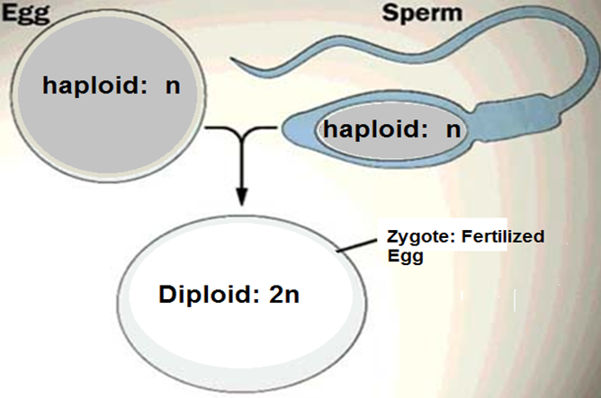

9.Each chromosome from your mother corresponds to a chromosome from your father. Corresponding chromosomes are called ____________________________________.

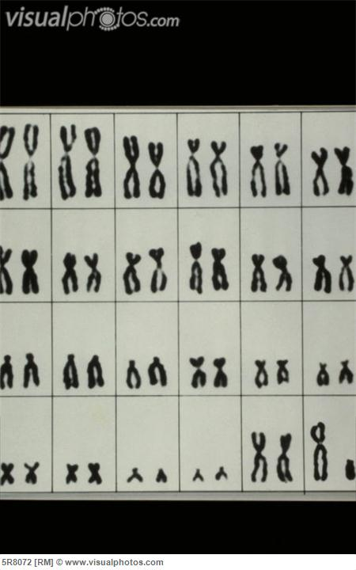Homologous chromosomes:

1. ___________________________________
2. ___________________________________
3. ___________________________________
4. ___________________________________

**Some things that happen in Meiosis are very different from Mitosis:**

13._______________ form when homologous chromosomes have paired up in the cell (4 sister chromatids lined up)

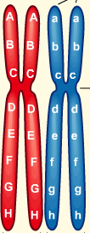

14._________________________: When segments of chromosomes break off and reattach to homologous chromosomes--_____________________________________

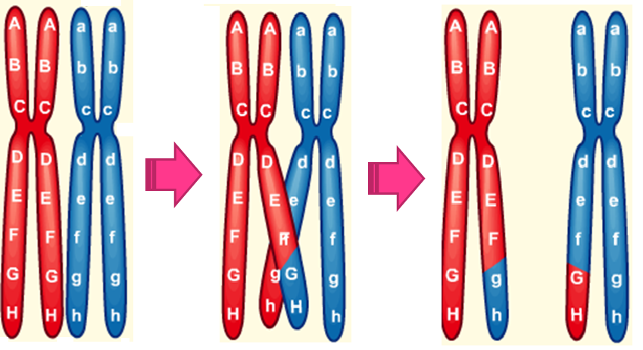

What will crossing over do to the genetic information that ends up in the daughter cells after meiosis?